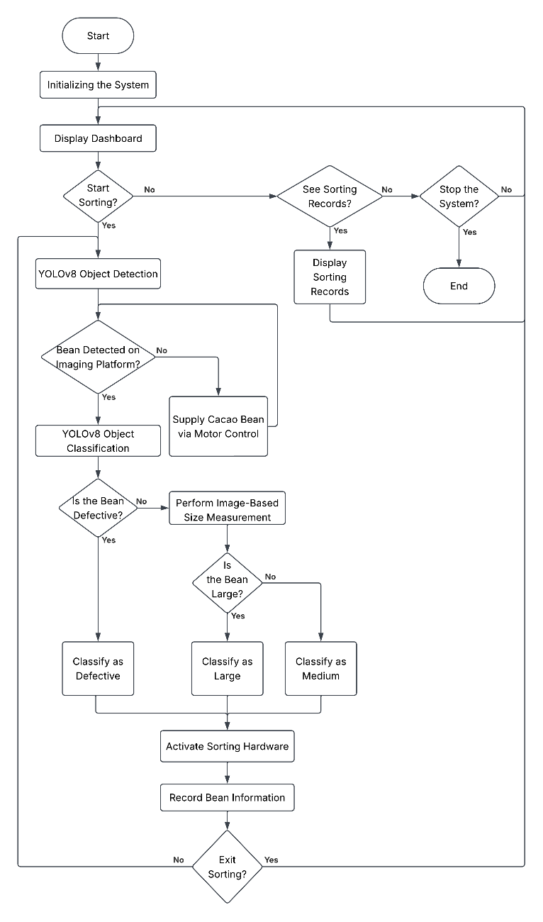

SYSTEM FLOWCHART

The system begins by initializing and displaying a dashboard, from which the user may choose to start sorting, view previous sorting records, or stop the system. Once sorting is initiated, the motor control mechanism supplies cacao bean to the imaging platform. The YOLOv8 object detection model analyzes the image of cacao beans on the platform to determine whether the bean is defective. Cacao beans identified as defective are immediately classified, while non-defective beans undergo an image-based size measurement to determine whether they are large or medium. Based on this classification, the sorting hardware is activated to move the bean into its assigned container, and the corresponding bean information is recorded before the system returns to check for the next bean on the imaging platform. This cycle continues until the user selects the option to stop the sorting process.

